**WEB DEVELOPMENT INFO 1213 (R95)**

**Final Project**

**Karan Singh**

**100395481**

This website showcases entertaining information for visitors. The main purpose of creating a cricket website is to provide knowledge about this game to the viewers. There are many people in this world who are crazy for cricket and want to know all the latest details about what’s going on in the world. So, it will be a really good idea to use that fanbase to create a very useful and beneficial website for both consumer and business.

This website will show all the latest fixtures, ongoing matches and upcoming matches. Along with that it will show all the results of the matches. It also gives detail about the current team ranking. Furthermore, this website shows all the rules about the game and it also shows the equipment which are popularly used in modern cricket.

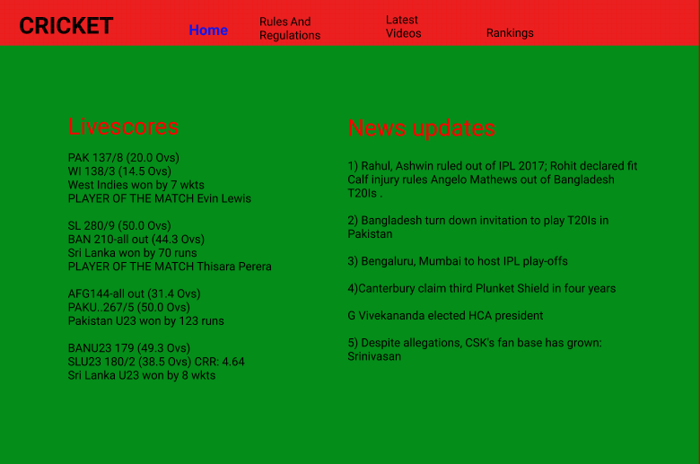

The difference between these two screenshots are the first screen shot has picture in background but second does not consist any picture . first one look like cricket field but second is just a points table of the teams with a simple green background .first one contains html whereas second one is figma. In first screenshot the letters are very small whereas in second all the letters are large and clear .

Link to goormIDE

<https://goor.me/vWa1D>

Paste this link in any web browser

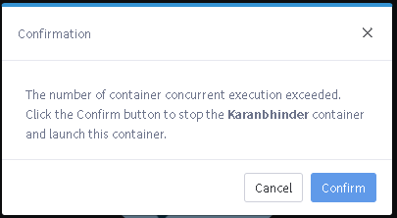

If this pops up, then click confirm.

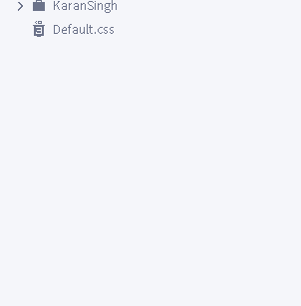

Then click on KaranSingh

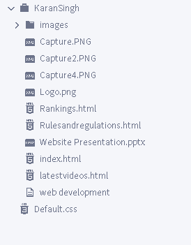

Then click on any html file and run the project.

In this website there are different tabs each must serve a specific function. First there is Home tab which will show all the basic information such as Live score of the ongoing matches and recently played matches. It uses different links which leads to a full scorecard of any match. Then there is another tab which will use video and text to make user understand the rules and regulations of the game. Followed by the tab with match highlights and all other latest videos. Finally there is a ranking tab which will show the standings in different tournaments. All these tabs use the same design with the help of a CSS file. This also uses the tables and graphs to show the detailed results. In this website whenever the mouse will hover over any tab it will change its color and if the tab is opened at that time also it will show up in different color. The complete website follows a fix layout throughout all the pages. On every page at top left corner there is a logo and at the bottom left there is signature watermark.